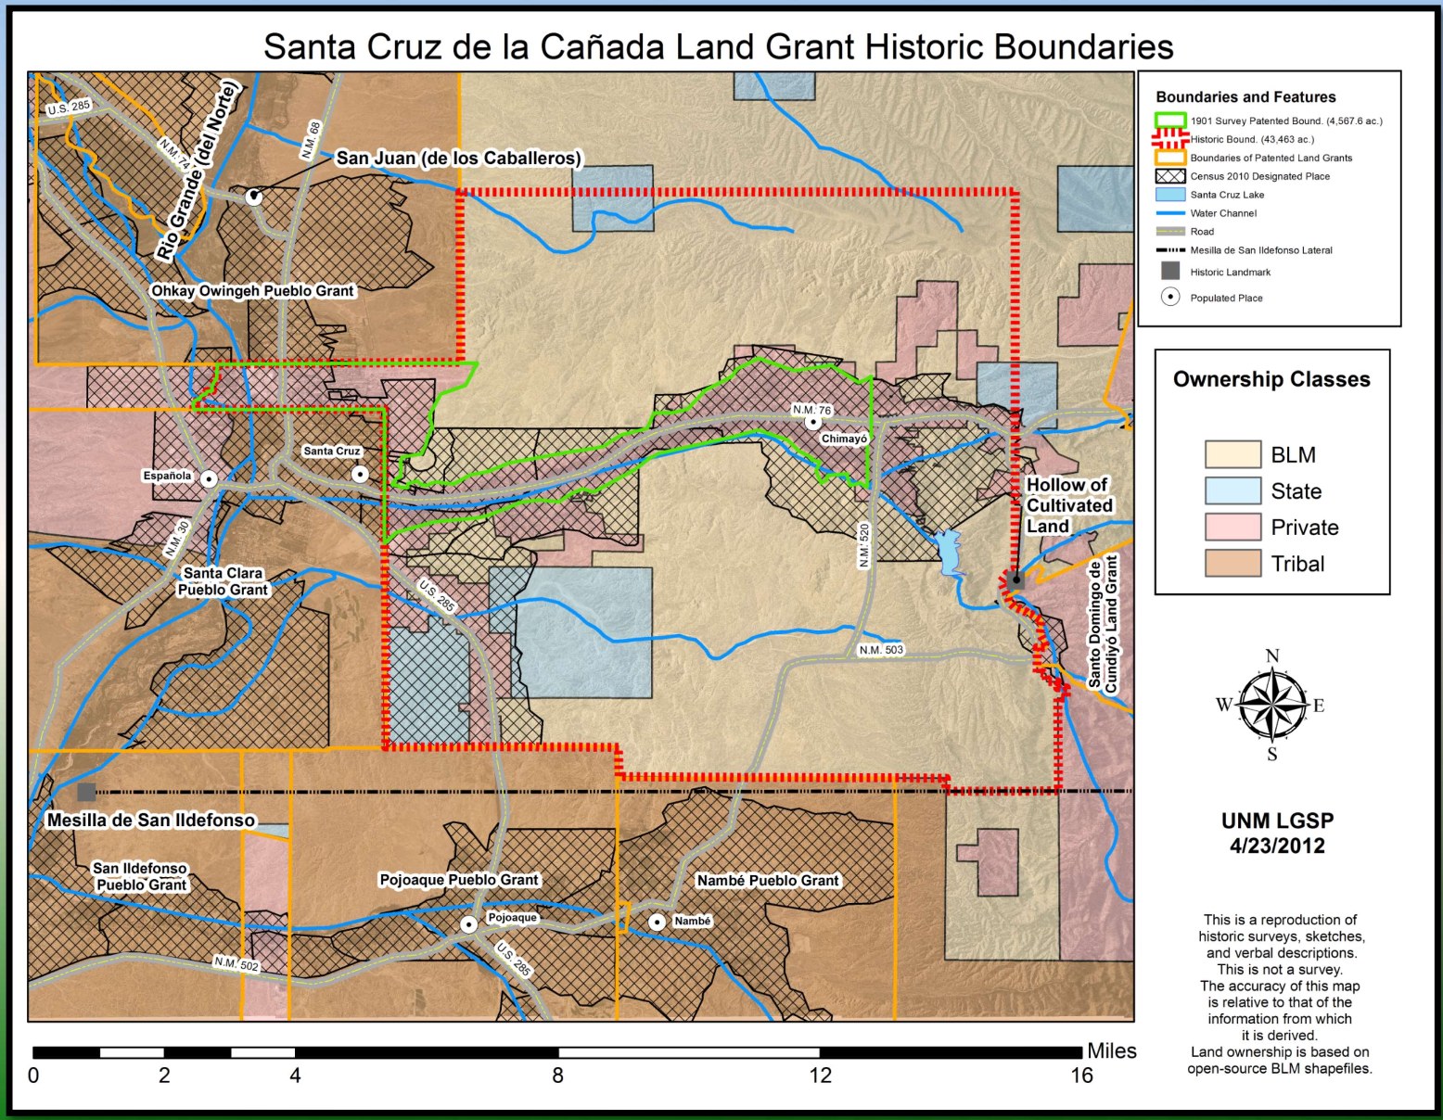**Santa Cruz de la Cañada Land Grant**

**Applicant Name:**

**Mailing Address:**

**Applicant Email**:

**Land Grant Ancestor:**

**Heirship Transfer Due to Incapacitation or Death:** [Add extra heirs if necessary.]

List children with a mailing address and an email (if available) of the applicant heirs to continue voting membership, this will help streamline transfers of heirship. See the grant by-laws regarding requirements for heirship membership and inheritance transfers of membership.

**Heir 1:**

**Heir 2:**

**Heir 3:**

**Heir 4:**

**Application Completion Requirements**

1. By completing the application, you authorize the Grant to publish your name on the website and your contact information on other administration documents.
2. The boxes in the data field will auto expand as data is entered; otherwise, do not change the field formatting.
3. The form should begin with the applicant and continue each generation that links you to the individual found to be an **original land grantee** or any individual found living within the Santa Cruz de la Cañada land grant boundaries using census records for the years 1707, and 1750 as your guide to verify your land grant ancestor. The census records can be found at: [santacruzgrant5.wixsite.com](https://santacruzgrant5.wixsite.com/website).
4. Completed form should be submitted to: [sclandgrant@gmail.com](mailto:sclandgrant@gmail.com).
5. Pedigree charts/trees/reports **will not** be accepted as an application.
6. Applications that include less than 7 generations will take longer to validate; delays should be expected. This is a volunteer organization, the validation team will not complete individual genealogies for the applicant.
7. Save the application document as a *.doc* file format so that the people validating the genealogy and your resources can insert their comments into the blocks. **Documents sent as a *.pdf* will not be accepted.** Be sure to use the applicant name/date in the file name, for example: *JohnDoe_geneaology.Feb2023*. We will return your document with validation notes and an email.
8. The center column is intended for listing any date related event that confirms the parents (next generation) such as birth, baptismal, marriage and death related records.
9. The right column is the source material for any of the date events in the center. Examples could be obituary information, birth, baptismal or marriage documents from church records (include sources).

|  |  |  |
| --- | --- | --- |
| Generation 1 Heirship Applicant | Date/Event | Source Material |
|  | Birth  Marriage  Death |  |

|  |  |  |
| --- | --- | --- |
| Generation 2 Parents | Date/Event | Source Material |
|  | Birth  Marriage  Death |  |

|  |  |  |
| --- | --- | --- |
| Generation 3 Grandparents | Date/Event | Source Material |
|  | Birth  Marriage  Death |  |

|  |  |  |
| --- | --- | --- |
| Generation 4 | Date/Event | Source Material |
|  | Birth  Marriage  Death |  |

|  |  |  |
| --- | --- | --- |
| Generation 5 | Date/Event | Source Material |
|  | Birth  Marriage  Death |  |

|  |  |  |
| --- | --- | --- |
| Generation 6 | Date/Event | Source Material |
|  | Birth  Marriage  Death |  |

|  |  |  |
| --- | --- | --- |
| Generation 7 | Date/Event | Source Material |
|  | Birth  Marriage  Death |  |

|  |  |  |
| --- | --- | --- |
| Generation 8 | Date/Event | Source Material |
|  | Birth  Marriage  Death |  |

|  |  |  |
| --- | --- | --- |
| Generation 9 | Date/Event | Source Material |
|  | Birth  Marriage  Death |  |

|  |  |  |
| --- | --- | --- |
| Generation 10 | Date/Event | Source Material |
|  | Birth  Marriage  Death |  |

|  |  |  |
| --- | --- | --- |
| Generation 11 | Date/Event | Source Material |
|  | Birth  Marriage  Death |  |

|  |  |  |
| --- | --- | --- |
| Generation 12 | Date/Event | Source Material |
| Hernán Martín Serrano II | Birth  Marriage  Death |  |

|  |  |  |
| --- | --- | --- |
| Generation 13 | Date/Event | Source Material |
|  | Birth  Marriage  Death |  |

|  |  |  |
| --- | --- | --- |
| Generation 14 | Date/Event | Source Material |
|  | Birth  Marriage  Death |  |

|  |  |  |
| --- | --- | --- |
| Generation 15 | Date/Event | Source Material |
|  | Birth  Marriage  Death |  |

|  |
| --- |
| **Validation Status** |
| **Reviewed By:**  **Date:**  **Approved/Rejected:** |
| **Notes:** |